Inside the sleep-deprived world of ultramarathon racing
They run for 12 hours from dusk to dawn, with battered feet and almost no sleep. Why?

for 12 hours from dusk to dawn, with battered feet and almost no sleep. Why?
By FIONA HARARI
From The Weekend Australian Magazine
February 18, 2023
With his floppy bucket hat and open plastic sandals, Philip Balnave looks more like a recreational fisherman than someone about to run the equivalent of two and a bit marathons. In a field of colourful athletic shorts and hundreds of worn-in running shoes, he’s a sartorial standout on this cool summer evening, yet his choice of food is even more striking. To fuel him as he runs through the night in a quiet pocket of Sydney, Balnave has chosen to munch on Chinese pork and chive pancakes.
“It’s the thing that saved me last time,” he says of his preferred diet, which, along with Bakewell tarts and chocolate soy milk, sustained him through an ultramarathon in early 2020 as he traversed a mighty 119km around this same dirt and concrete circuit.
Three years on, and after a bus ride from his home on the other side of Sydney (he detests cars almost as much as he loves running), Balnave is back at Narrabeen Lagoon with spare clothes and sandals, a bag of food and, given his drop in race fitness post-Covid, hopes of covering a good 80km while most of the city sleeps. “There’s no strategy,” he says of his minimal preparations to join a field of 101 all-night runners. “You just rock up and hope.”
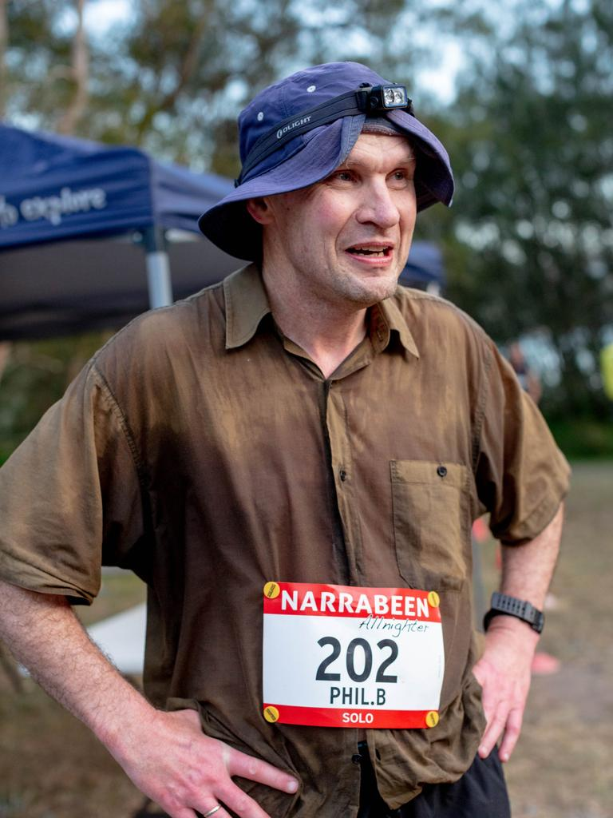Philip Balnave. Picture: Marilia Ogayar
In the world of ultramarathons, definitions, like strategy, can be elusive. “There’s no one definition of ultra running,” says Alexis Oosterhoff, a committed competitor and former vice-president of the Australian Ultra Runners Association. “It’s simply anything over a marathon.” Races can span time (12 or even 48 hours are fairly common) and length. At 102 years old, South Africa’s annual Comrades marathon is the world’s oldest; with up to 25,000 competitors, it is one of the biggest and is run over a distance of 89km.
In a calendar bursting with events ranging from France’s elite 100 mile Ultra Trail Mont Blanc to New York’s Sri Chinmoy Self-Transcendence race, where competitors run 5000km around the same city block over 52 days, the Narrabeen Allnighter is more pedestrian than prestigious. With its mostly flat loop that skirts the lagoon and several suburban streets, “it’s a run-of-the-mill race,” says race director Ron Schwebel. Still, dozens of enthusiasts have rocked up late on this Saturday, paid their $150 entry fee, and, well before the sun has even started to dim, are lined up at the haphazard white chalk starting line scrawled over a patch of grass.
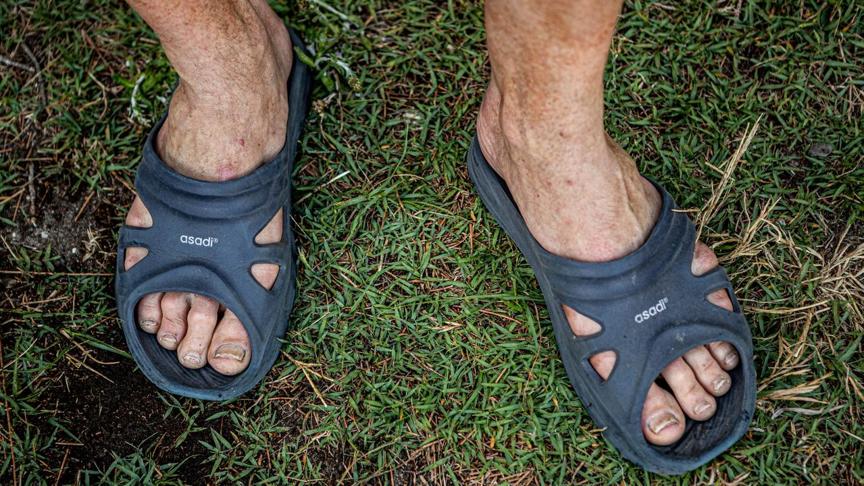Philip Balnave's feet before the race. Picture: Marilia Ogayar
For the next 12 hours they will run along a mostly unlit circuit that, at 5.275km, is exactly one-eighth of a marathon, sometimes scampering through bushy tracts, dodging tree roots and rocks and patches of track eroded by rain. Running on and on, their most reliable companions will be the headlamps that guide them through the darkness, and solitude. Some will compete as tag team duos, taking alternate laps, but most will run on their own. By the time they stop and the sun has risen, the best of them will have run the equivalent of three successive marathons.
For their efforts, a handful will receive trophies. The majority will leave prizeless. Yet the most notable feature among those still standing at dawn will be an enormous well of satisfaction at having achieved something that many outsiders struggle to fathom. As one enthusiast says of his sport’s allure: “There are people who are running to win. But most of us are just doing it to get to the end.”
Sleep? It might be the late-night goal of others setting out this evening, but for the couple of hundred people gathered at bushy Jamieson Park, a few metres from the shore of Narrabeen Lagoon, it’s tomorrow’s problem. With the sun still high, the atmosphere at the instant camp that has appeared near the starting line is festive, fairy lights and spotlights strewn across some of the many tents that have popped up over the past few hours, We Are the Champions pumping out from a portable speaker, and everywhere tables laden with food.
To run an ultramarathon takes strength and endurance. It also often includes a cast of dedicated supporters, not just for moral assistance but to manage the tricky balance of ensuring competitors are properly fuelled. Runners can’t drink too little but they also risk developing hyponatremia, or low blood sodium levels, if they drink too much. As for food, plenty seems to be the consensus, in quantity and variety.
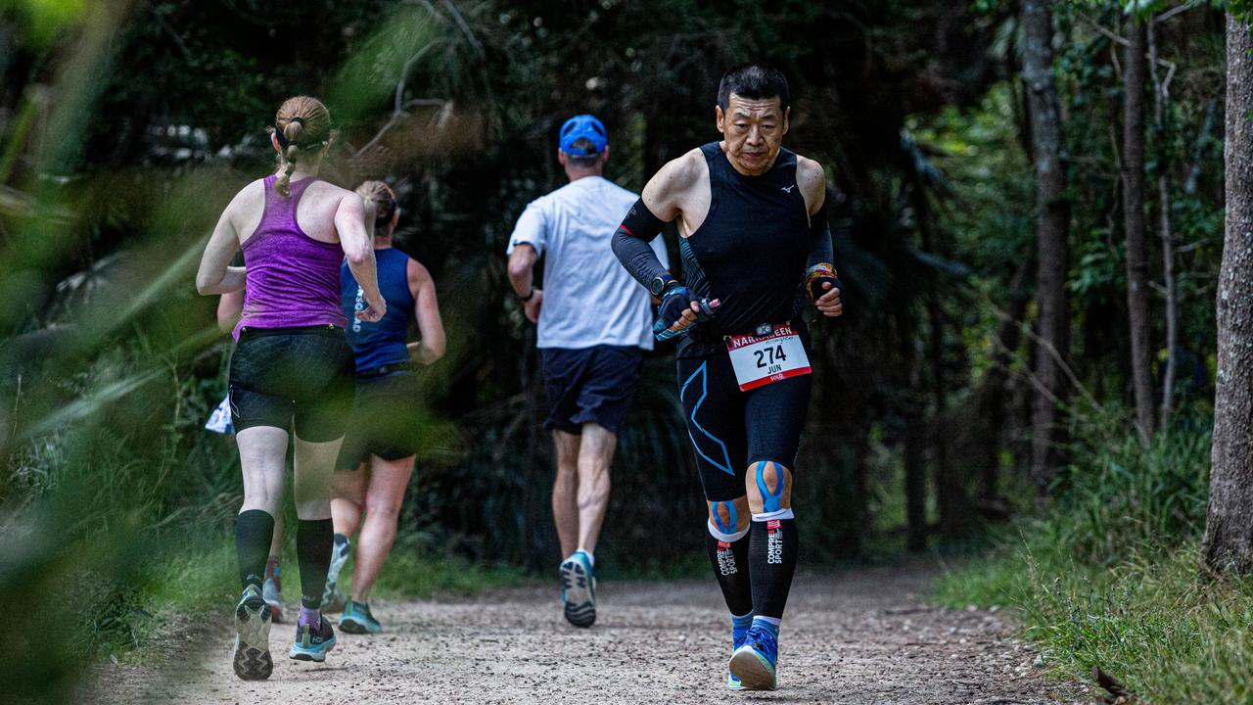Some run the whole way, some walk for a few laps. Picture: Marilia Ogayar
At tented tables that have sprung up around the starting line, spreads seem almost fete-like, with dates, chips, Cheezels and baby food awaiting hungry runners, as well as jelly snakes and energy bars. There’s a bit of fruit – one woman swears by the sustaining benefits of watermelon – and a lot of carbs. “Come 2 or 3 o’clock in the morning, where their circadian rhythms come in, they’re going to start zigzagging if they don’t eat,” says Mel Crick, who has brought along, among other things, impressive quantities of buttered potatoes, bags of chips and a nutritional supplement that she and her husband, Anthony, with whom she is sharing the race, will down between laps.
For her first overnight ultramarathon Kaye Stanton has arrived with an Esky stuffed with electrolytes and high-calorie gel snacks, bananas and sandwiches. She has no supporters here and has only even informed one friend about her overnight plans. “I find if I tell people way before you get all sorts of comments: ‘Why are you doing that? You’ll just kill yourself.’ People don’t understand.”
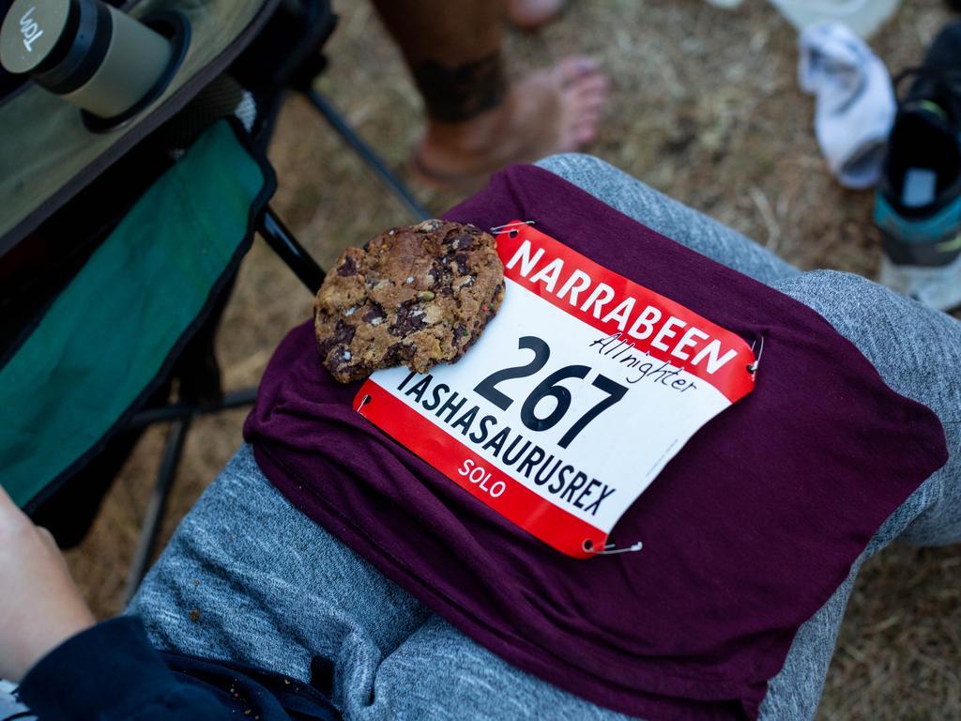There’s no shortage of snacks waiting for the runners. Picture: Marilia Ogayar
A former cross country runner in New Zealand, Stanton recently resumed running after 30 years. At 61, she is the oldest female competing tonight. “I decided when I turned 60 that this was a whole new era for me and it was ‘Go girl’,” she says between mouthfuls of pasta salad in the hour before the race starts. Realising that she won’t come first, she’s approaching the event more as an adventure, excited about the night ahead, the silence and stillness of the dark hours, and the meditative rhythm of running beneath the halo of a single head lamp. “Running has helped me through everything that’s been challenging in my life – depression, anxiety – and it’s one thing that I have always been reasonably good at,” she says. “I get away from any little worries and hassles that are niggling away at me about life and responsibilities and grief.”
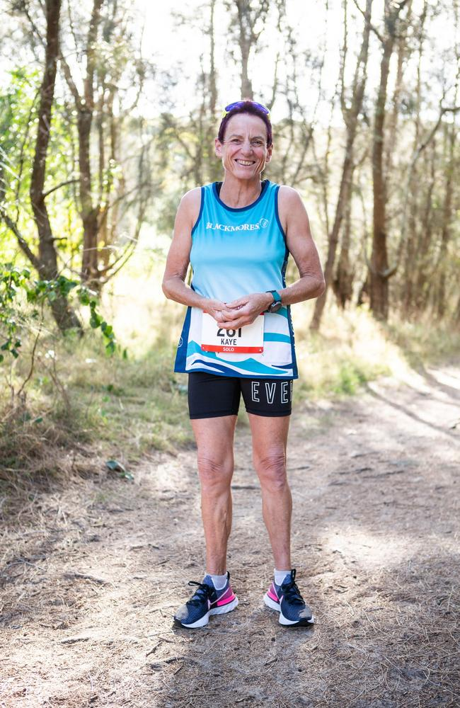Kaye Stanton turned to ultramarathons to help “get away” from everyday stresses. Picture: Marilia Ogayar
That she will only think in the coming hours of herself and what she needs to run for so long has brought some unexpected light into her life after 30 years of mental health darkness. “I’m just excited to be here. I’m excited to be alive,” she says with a grin as she emerges from the tiny tent that will serve as both a holding pen for her Esky and a potential resting spot over the coming hours.
When you’re running for 12 hours, the issue of rest is hard to avoid. But how and when is also debatable. “There’s a saying, ‘Beware of the chair’,” says race director Ron Schwebel, 71, who ran his first ultramarathon in 2005 and who is no fan of pausing to sit mid-race because of the agony that can ensue when you then stand up. “The common thing you’ll hear people say is ‘I am never doing this again’ at the end when they’re getting out of a chair.’” Much like childbirth, a week or so later, he says, they will invariably have changed their minds and be signing up for the next race.
-
“There’s a sort of addiction or compulsion to do it”
-
“There’s a sort of addiction or compulsion to do it,” says Schwebel, who gathers the overnight runners at the starting line just before 6pm for a low-key briefing. Then he simply calls out “go”, and, accompanied by the gentle swoosh of dozens of shoes hitting a dirt track, they are off.
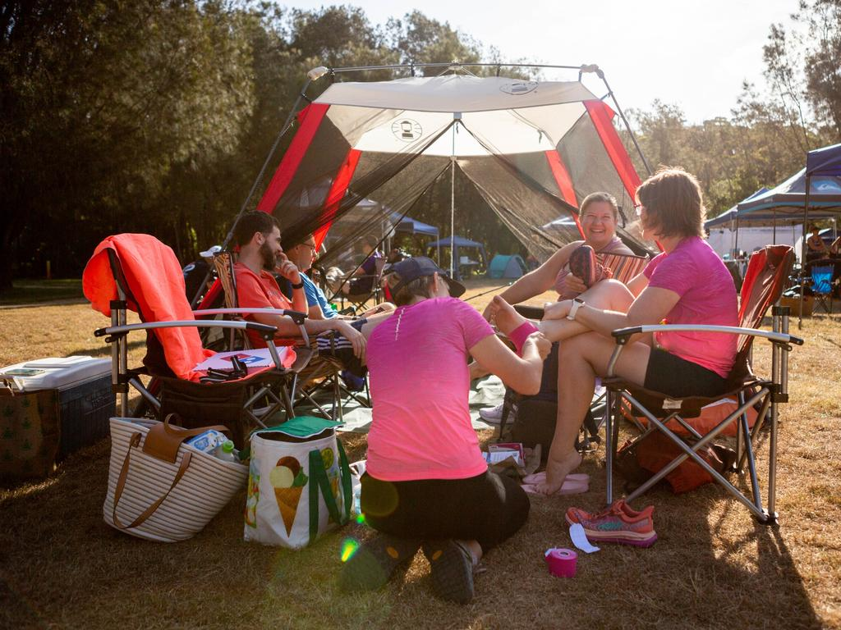Supporters wait at Jamieson Park in Narrabeen on Sydney’s northern beaches. Picture: Marilia Ogayar
The festive air follows the runners at first as they pass palm fronds and fallen trees, sharing the path with the odd cyclist and walker on a route that eventually opens to suburbia, passing a retirement village and a golf course. One competitor is joined by her husband and two young sons for several hundred metres. Others run in pairs, chatting easily.
An hour in, most runners are still smiling. In the leadup to a spectacular sunset, a flock of kookaburras sounds as two women pause by the side of the lagoon to snap selfies. Then, as the sky darkens and the first headlamps are illuminated at 7.30, the air stills and amid the constant pounding of shoes and huffing of humans, the waves crashing just a few kilometres away can suddenly be heard.
With his running shorts his only concession to sporting attire, Philip Balnave jogs on, his buttoned brown shirt soaked at the back and billowing in the breeze. At 55, he spends his working days as an electrophysiologist, but his heart belongs here. “How can you not run? I’ve run since I was a kid; you run and just keep running. It’s part of my life, it’s just how I get around,” he says. “I’ve always just run everywhere. I run to the shop, to work. I’ve got all the children trained up to scooter if they don’t run with me.”
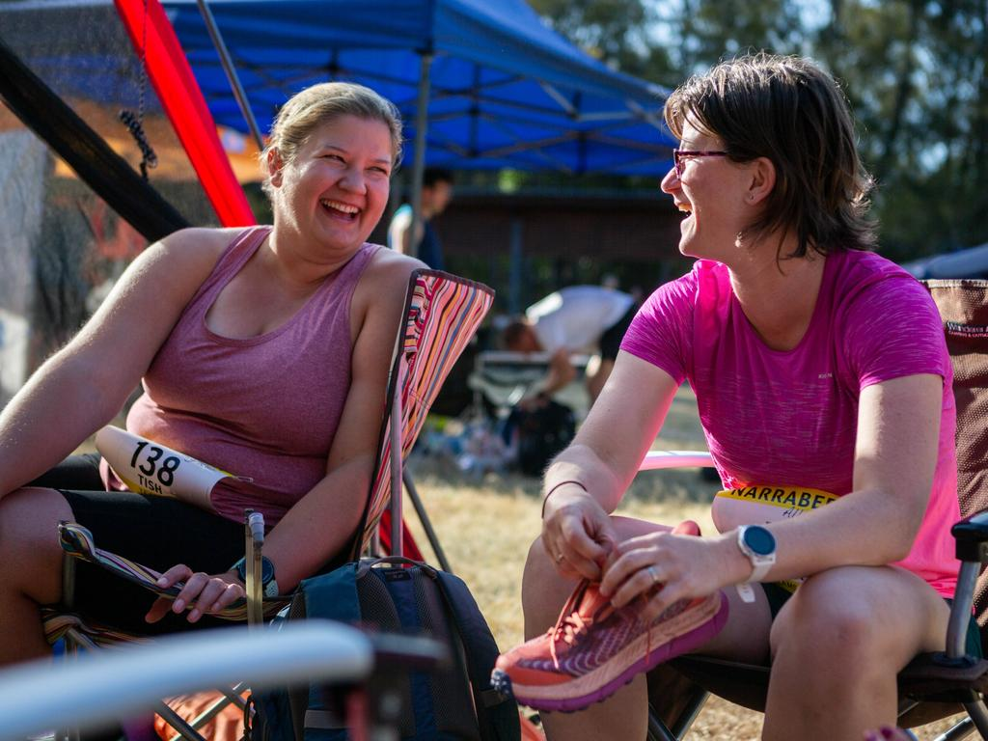They race from 6pm till 6am, running the equivalent of two and bit marathons. Picture: Marilia Ogayar
By 10pm, and having swapped one pair of plastic slides for a different style that he finds has more cushioning, Balnave, despite his own concerns about a lack of form, shows no signs of flagging. “My legs haven’t cracked yet,” he says as he rummages through the bags he has dumped on a grassy verge, grabs a strawberry and begins another lap. Eight more hours to go.
Running in the dark, and for so long, carries its own concerns. Tired runners tend not to lift their feet as high and risk tripping, and with only minimal light coming from their headlamps they tend to move more slowly and with less certainty.
While she finds the darkness initially meditative, after five hours Kaye Stanton is spent. She needs to eat more, but is feeling so nauseous that she has to force herself to consume anything. Having already run the equivalent of a marathon, she spends the final 40 minutes of Saturday resting in her tent.
By the time Sunday begins, and a fresh batch of runners temporarily joins the course for a midnight marathon, one woman has already completed 58km. But any jubilation is muted at this hour, when most of the all nighters are progressing alone and in silence but for the whistling of insects and the occasional puffing of a passer-by. Stanton resumes her race, embracing the silence, annoyed when it is broken by noisy midnight marathon runners. “I felt like saying, ‘You’re disturbing the peace guys.’” While some tranquillity is restored as the midnight participants gradually complete their circuits, for those running for 12 hours, the hardest time is yet to come.
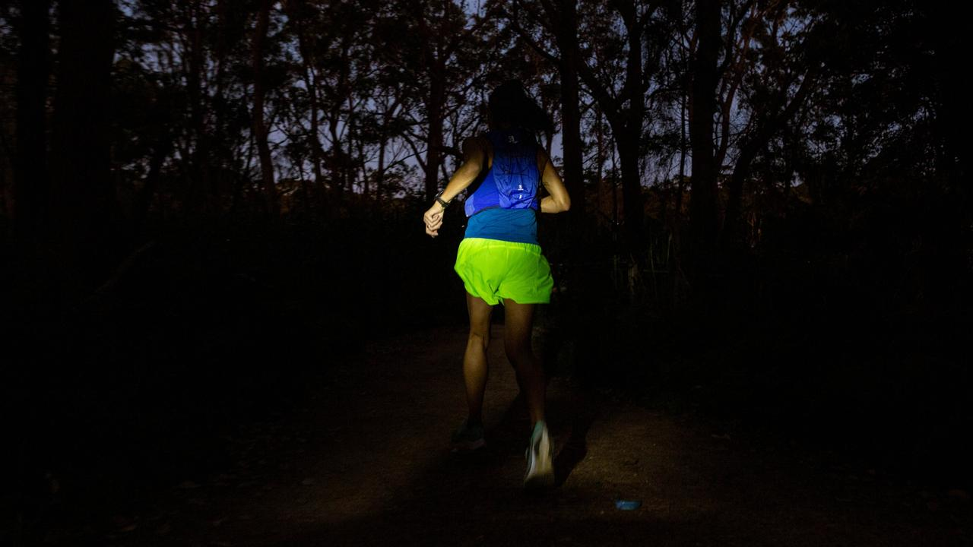By Sunday, a fresh batch of runners temporarily joins the course for a midnight marathon. Picture: Marilia Ogayar
“If it wasn’t a race I could quite easily go home now,” one competitor, who is taking on alternate laps with a mate, says at 3am. In contrast to the weariness of runners, the race camp is still thrumming. A few people are dozing in sun chairs, but most are awake, wearing puffer jackets and hoodies, chatting and watching sport on their phones and waiting to feed their athletes at the end of each lap. Under a large picnic shelter organisers battle poor internet reception and a failing generator, compounding their middle of the night efforts to post updated times on to an oversized screen.
-
The Narrabeen All Nighter is more pedestrian than prestigious
-
For Stanton, this is the roughest hour. Between 3 and 4am she walks a little, startled by a possum that runs across the track, “willing myself to keep going”, and naps briefly in her tent. Apart from exhaustion, the darkness is a greater challenge than she expects. Although it enables her to clear her mind, she underestimates the challenges of running through it, guided only by her headlamp, and the level of concentration it requires.
In this final stretch of night, many runners are shuffling or walking. Apart from the occasional high five at the starting line, when tag-teams swap over, even the energy level at the impromptu camp is low. In the adjoining bush, competitors continue to pass one another regularly, but the intervening seconds seem long and the darkness intense.
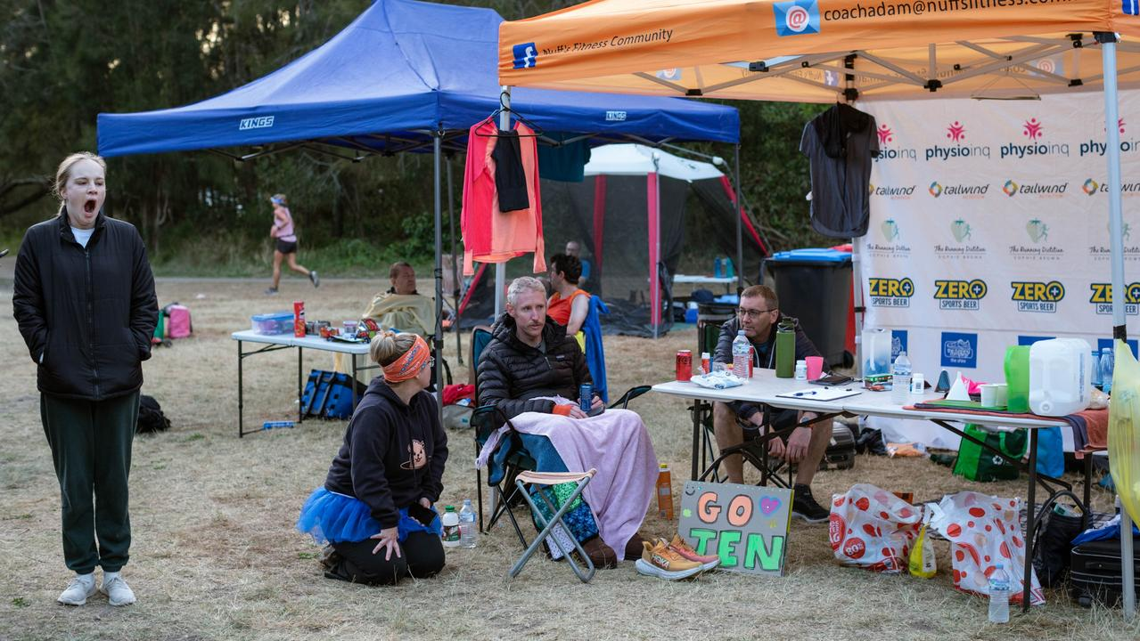Competitors and supporters wait at tented tables set up around the finishing line. Picture: Marilia Ogayar
By 4.30, an hour before sunrise, at least one runner is limping. The generator used for scoring continues to fail, and when it eventually comes good, a pair learns that they have already run 100km between them. As the sky begins to lighten half an hour later, the first of the headlamps, whose steady bobbing has marked the course overnight, are switched off. Even more competitors are limping. By the time the sun rises at 5.37 they are on their final laps.
The clock stops exactly 12 hours after race director Schwebel has yelled “go”. By 6am, everyone needs to have completed their final circuit. The last runner crosses the finish line just 12 seconds before the 12 hours expires. Among the hobbling bodies, the toll includes one bleeding leg, a pair of feet needing an intense ice bath, and multiple enormous blisters.
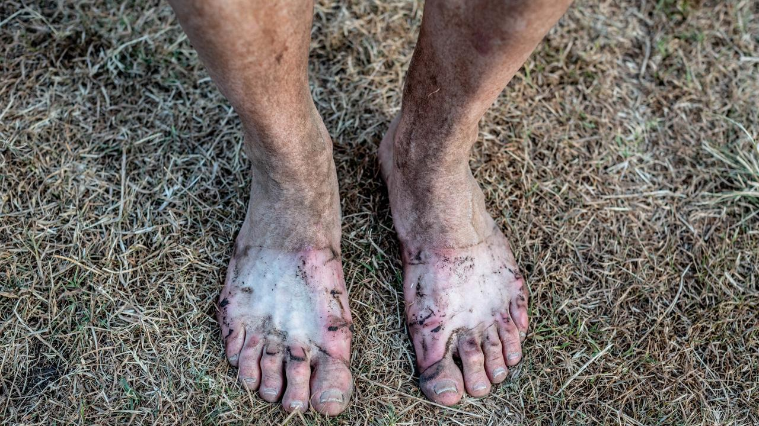Philip Balnave’s blistered feet after the race. Picture: Marilia Ogayar
Mostly, though, there is satisfaction oozing from all the tired bodies. One runner whoops jubilantly in the morning light when he learns that he has broken his own record and run more than 100km. Many runners look knackered but a few also look remarkably refreshed. After a sleepless night on the go, almost everyone seems happy.
Kaye Stanton runs for 11 hours, 31 minutes and 43 seconds. She covers 73.8km – or 16 laps, not quite the 18 she had envisaged – and although she was spent four hours ago, she is now thrilled. “I’m just happy it’s finished,” she says moments after she stops, exhausted and joyous. “It was awesome. I’m in too much pain to feel good about it at the moment.” While she’s still catching her breath, she also can’t stop smiling.
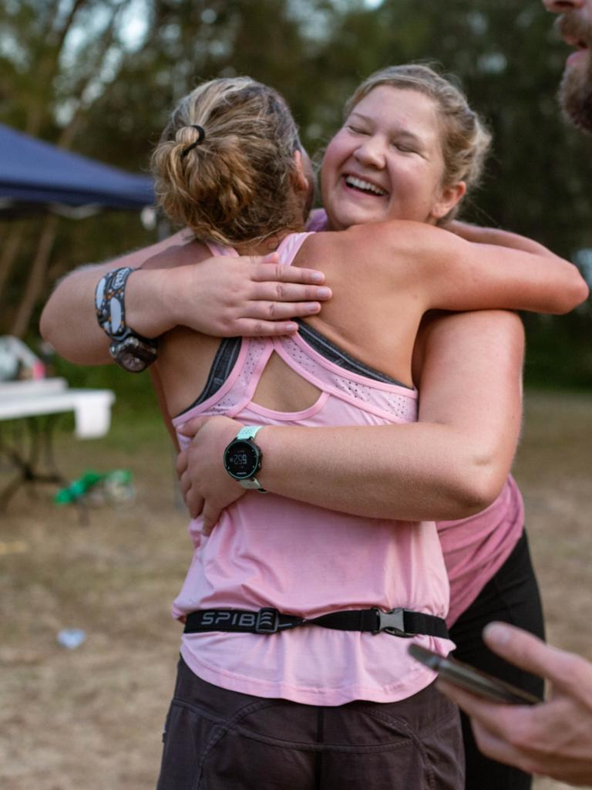Embracing when it’s all done. Picture: Marilia Ogayar
By the time Phillip Balnave finishes his final lap, aided in earlier stages by listening to music and audio books, he has run for 11 hours 53 minutes 19 seconds. “I thought at one stage I would never get going again.” The race is tougher than he, too, expects and he walks several laps. “My pork and chive pancake didn’t really work. Maybe they cut back on the salt.”
Although it’s far from his best distance, and his own course record for his age group is broken by another competitor, he runs an impressive 89.6km – considerably more than the 80km he had hoped. And despite concerns that his legs would fold after 50km, in the glow of a new day his plastic sandal-shod feet, although dirtied and pocked, feel just fine.

FIONA HARARI
WRITER, THE WEEKEND AUSTRALIAN MAGAZINE
Follow
Fiona Harari is an award-winning journalist who has worked in print and television. A Walkley freelance journalist of the year and the author of two books, Fiona returned to The Australian in 2019 after 15 years.... Read more

